**Name: Kartikeya Narian Khanna**

**SAP ID: 50078285**

**Roll No: R171219049**

**Course: B.Tech CSE Devops**

**Batch: 2**

**Build and Release Management Lab-5**

**Aim:** Install Site Plugin and use “mvn site” command and goal for generating documents for Maven Project using Eclipse.

1. Create a simple maven project.

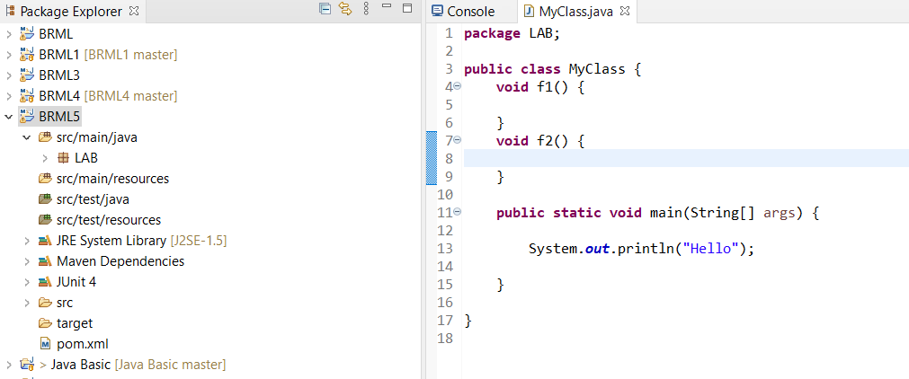

2. Add Dependency in pom.xml File

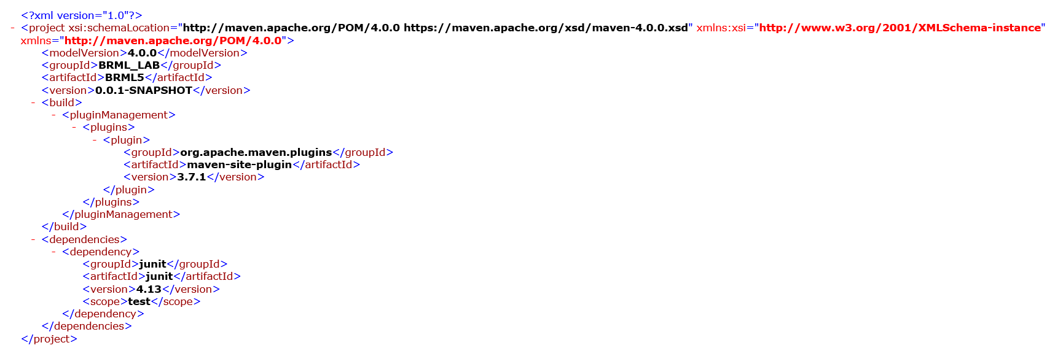

3.Run Site Goal

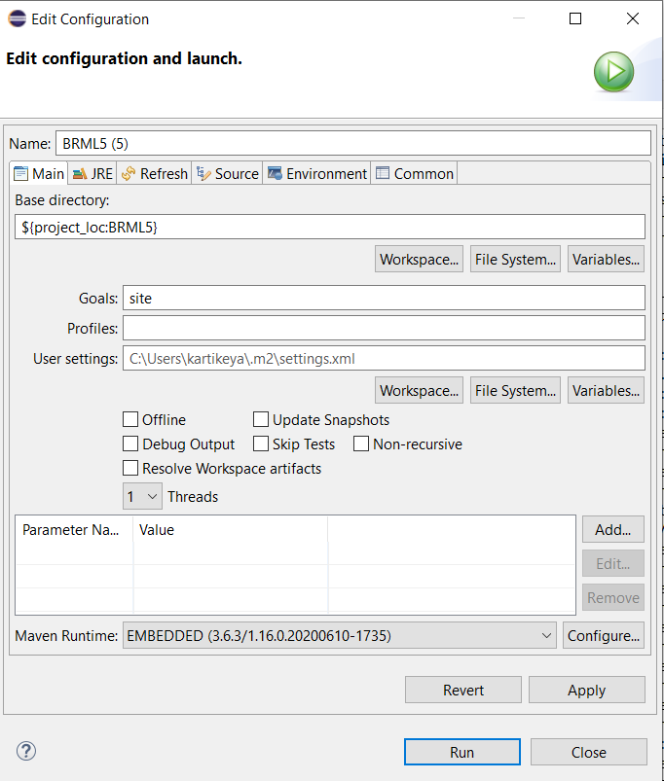

4.Output of Site Goal

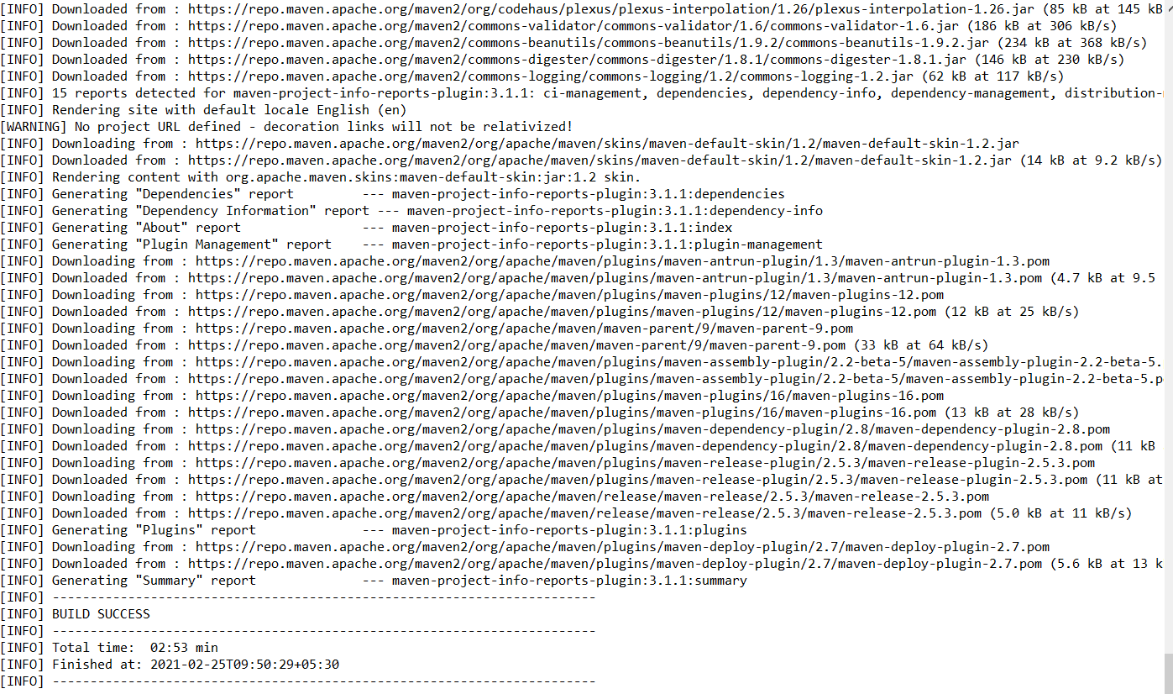

5.Files Generated

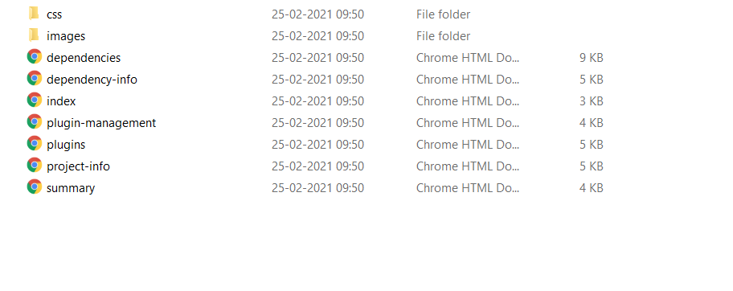

6.Dependencies File

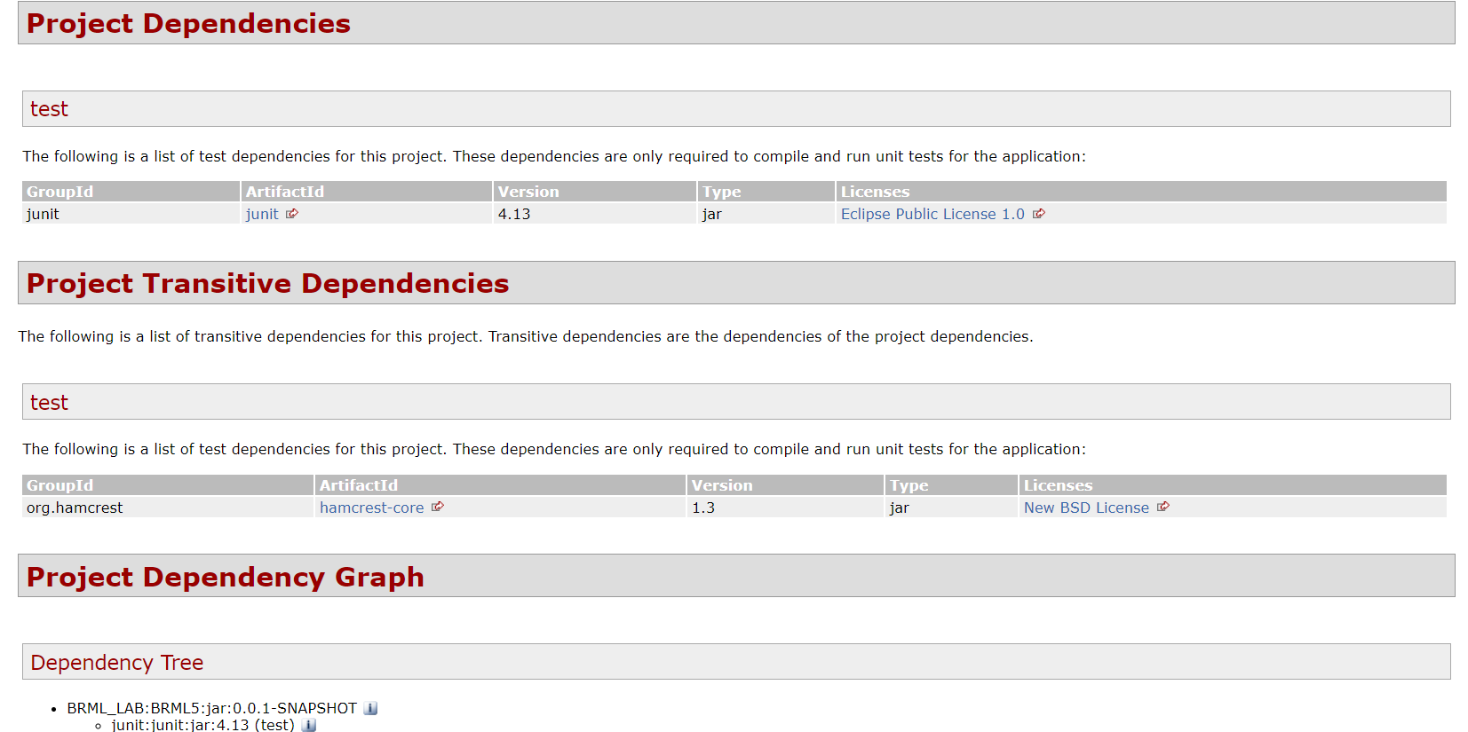

7.Dependency-info File

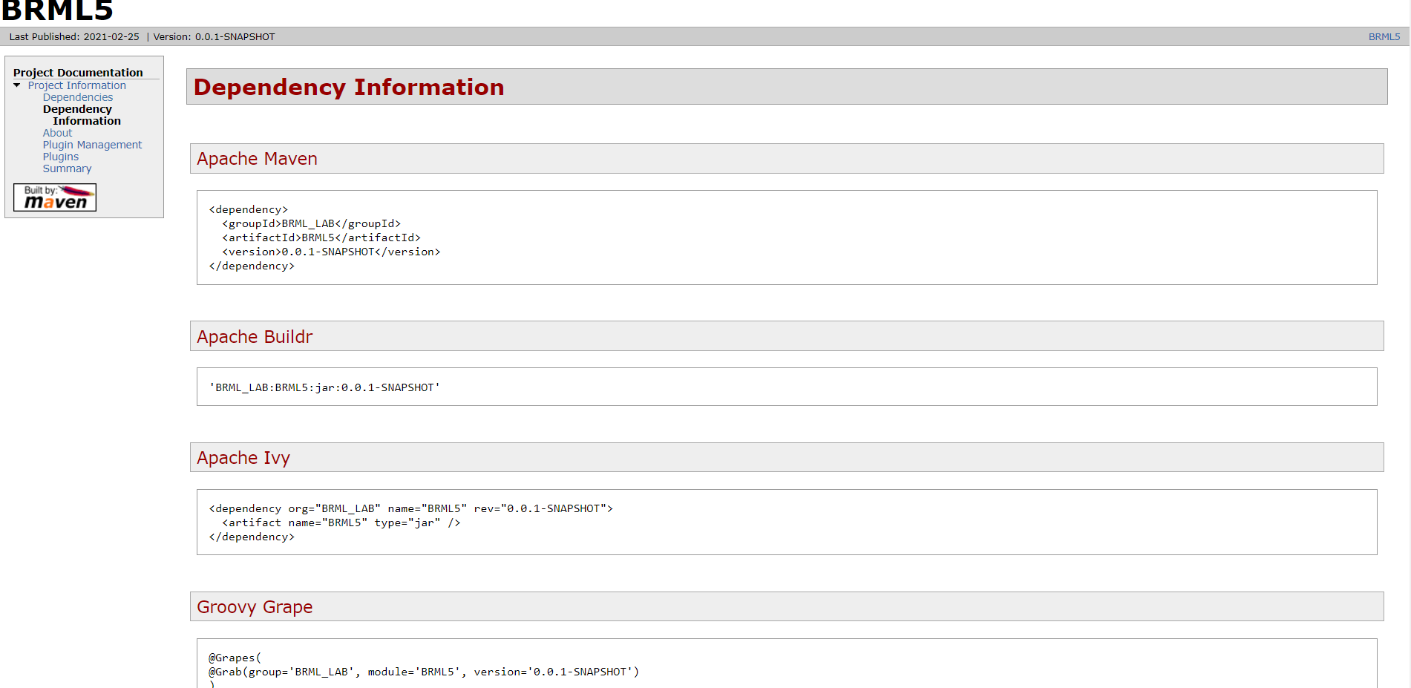

8.Index File

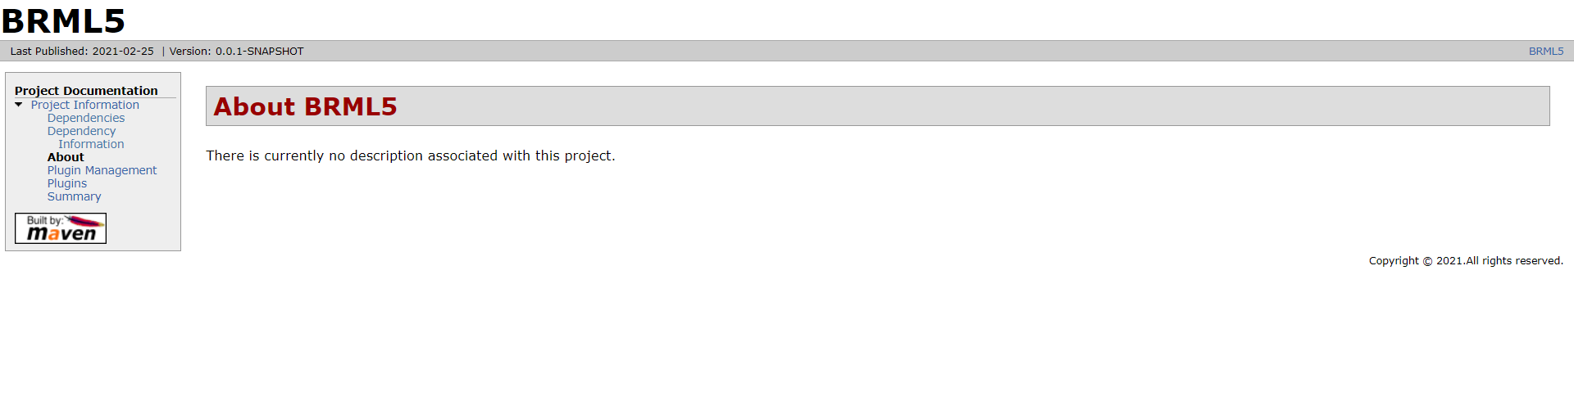

9.Plugin-Management File

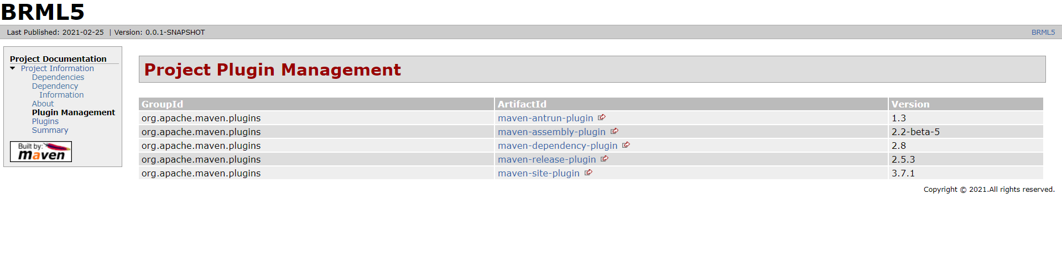

10.Plugins File

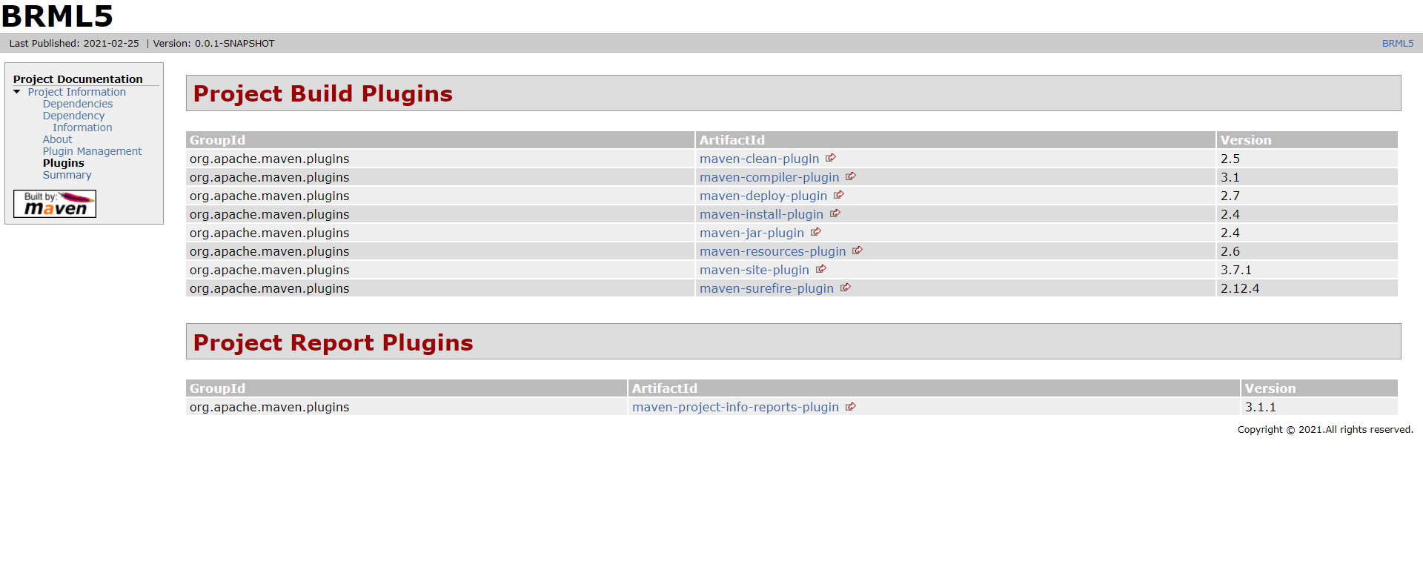

11.Project-Info File

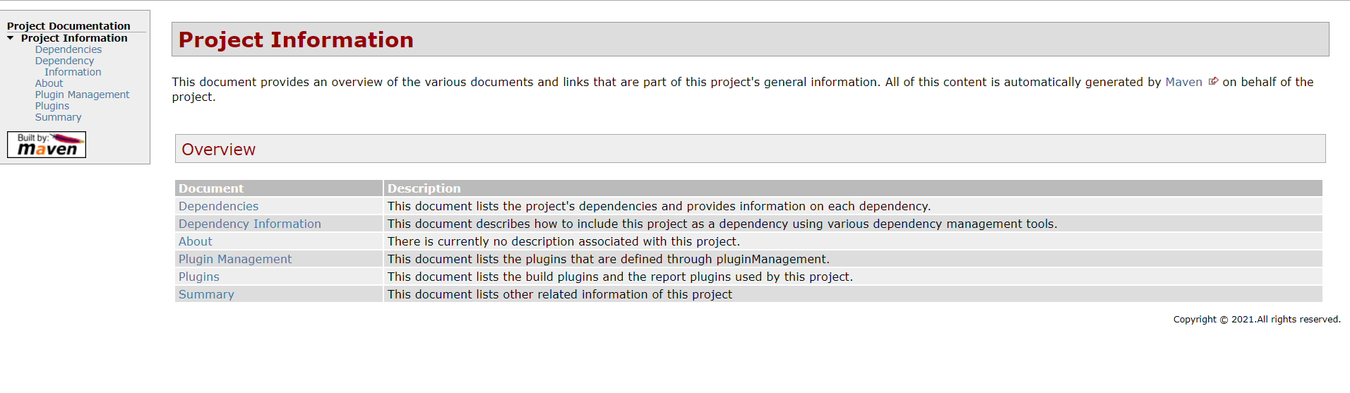

12.Summary File

